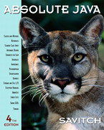 COSC 1320
Name: _________________ Seat # ___

Estimated Hours 1
Actual Hours

TA (Textual Analysis) for UML USE CASE Diagram MODEL
Programming Assignment 1:
(10 points)
(Due date found in the COSC 1320 BB Calendar!)
You must use Microsoft WORD program. Insert the TEMPLATEs for Actors and Use Cases in this Requirements Document.

Please have Step 1, 2, 3, and 4 in this order.

PLEASE use the “TA for UML USE CASE Diagram MODEL Movie Company System.doc” AS TEMPLATE.
(Do not Show STEP 1,…; do not change Line Numbers; do not change Number of Pages)

Any DIAGRAM that is NOT the result of CUT and PASTE
WILL BE IGNORED. (YOU WILL GET ZERO POINTS)

Requirements Analysis: Construct the UML Use Case Diagram MODEL

Requirements Analysis: Construct the UML USE CASE Diagram MODEL

ProgrammingAssignment1 APPLICATION to automate adding, deleting, and displaying the list of employees in a hospital.
The set of Classes define these employees of a hospital: hospital employee, doctor, nurse, administrator, surgeon, receptionist, and janitor. MUST use inheritance in creating these Classes. You can use arrays to store objects of the same Class, you can assume MAX_SIZE = 5 or one array to store all objects of all the Classes, you can assume MAX_SIZE = 20.
(you are not to import java.util.*; - failure to conform will result in losing 20 points; you are not to use JCL ArrayList or LinkedList or Vector Classes - failure to conform will result in losing 40 points; you are to use an C array - failure to conform will result in losing 30 points)

These employees are initially read and added from the “Programming Assignment 1 Data.txt” and are also saved in same file when your ProgrammingAssignment1 APPLICATION terminates.

Your ProgrammingAssignment1 APPLICATION must read in the data file (FILE INPUT) into your ProgrammingAssignment1 APPLICATION memory (please DO NOT read from File and write to File skipping reading into the program memory).

Your ProgrammingAssignment1 APPLICATION must allow the user to delete a hospital employee, doctor, nurse, administrator, surgeon, receptionist, and janitor given the role and the name.

Your ProgrammingAssignment1 APPLICATION must allow the user to add a hospital employee, doctor, nurse, administrator, surgeon, receptionist, and janitor.

Your ProgrammingAssignment3 APPLICATION must allow the user to display the hospital employees in the format given below.

Your ProgrammingAssignment3 APPLICATION must allow the user to save the hospital employees before it exits from the ProgrammingAssignment3 APPLICATION from the memory to the SAME data file (FILE OUTPUT) “Programming Assignment 1 Data.txt”.

Use Constructors to automatically initialize the instance variables that MUST be declared private - failure to make ALL member variables private will result in losing 20 points. Appropriate accessor and mutator methods for each private instance variable must be created.

Add (overwrite) the methods to display (must use toString method and super - failure to use toString will result in losing 10 points; - failure to use super will result in losing 10 points).

MUST use inheritance in creating these Classes - failure to use inheritance will result in losing 20 points).

A sample input file “Programming Assignment 1 Data.txt” follows:

h Vito 123
d Michael 234 Heart
n Sonny 456 6
a Luca 567 Business
r Tom 678 Talking Y
j Anthony 789 Maintenance N
d Nicos 891 Bone

The h stands for hospital employee role, Vito for name (only one string), and 123 is its hospital employee number.

The d stands for doctor, Michael for name, 234 for number, and Heart for specialty.

The s stands for surgeon, Vincent for name, 345 for number, Brain for specialty, and Y for operating.

The n stands for nurse, Sonny for name, 456 for number, and 6 for numpatients.

The a stands for administrator, Luca for name, 567 for number, and Business for department.

The r stands for receptionist, Tom for name, 678 for number, Talking for department, and Y for answering.

The j stands for janitor, Anthony for name, 789 for number, Maintenance for department, and Y for sweeping.

Format to display the Hospital Employees use the following format (must use the toString() method):

The Hospital has the following employees:

Hospital Employees: 1
Name: Vito Employee Number: 123

Doctors: 2
Name: Michael Employee Number: 234 Specialty: Heart
Name: Nicos Employee Number: 891 Specialty: Bone

Surgeons: 0

Nurses: 1
Name: Sonny Employee Number: 456 Number of Patients: 6

Administrators: 1
Name: Luca Employee Number: 567 Department: Business

Receptionists: 1
Name: Tom Employee Number: 678 Department: Talking Answering: Y

Janitors: 1
Name: Anthony Employee Number: 789 Department: Maintenance Sweeping: N

Total number of Employees: 7

Create a ProgrammingAssignment1.java that contains the main method.

PLEASE DO NOT INCLUDE THESE PAGES AS YOUR DELIVERABLES! This is just for your reference. This is the TEMPLATE that you are to use for your Programming Assignment.
TA (Textual Analysis) for UML USE CASE Diagram MODEL
for Movie Company System
A1: User

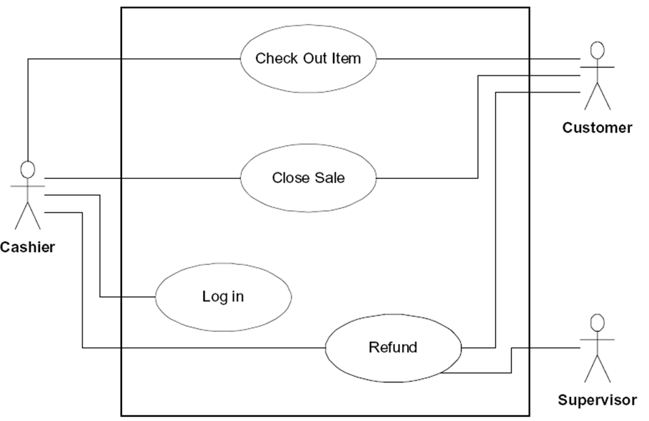

The Movie Company has the following affiliated Artists (maximum 10):

“Miles Davis”, with 3 Discs:
Disc 1: Title “Miles Ahead” with Track “Miles Ahead” that is 3.34 minutes
Disc 2: Title “Tutu with Tracks: “Tutu”, 4.56, “Portia”, 3.34, “Tomaas”, 3.56
Disc 3: Title “Kind of Blue” with Tracks “So What”, 4.54, “Freddie Freeloader, 5.25, “Blue in Green”, 2.56
“John Coltrane”, with 1 Disc:
Disc 1: Title “Blue Train” with Blue Train” that is 5.15 minutes; “Moments Notice”, 5.52, “Locomotion”, 6.18

The Movie Company wants to keep a catalog of its artists and their discs (maximum 30). Artists have a name. The Movie Company can add an artist or get a listing of all its artists.
UC1: UCAddArtist
UC2: UCListArtists
Each artist produces music Discs. A Disc is associated with an Artist. A Disc is cataloged with a disc catalogNumber. The Movie Company can add a disc or get a listing of all its discs.
UC3: UCAddDisc
UC4: UCListDiscs
A Disc has a number of Tracks. The Track has a title and a duration time. A Disc has a catalogNumber , a title, the number of tracks. The Movie Company can add a track or get a listing of all tracks for a given disc.
UC5: UCAddTrack
UC6: UCListTracksForDiscs
UC7: UCRestoreCatalog
UC8: UCSaveCatalog
UCAddArtist
UCListArtists
UCAddDisc
UCListDiscs
UCAddTrack
UCListTracksForDisk
Controller

UC 1

UC2

UC3

UC4

UC5

UC6

UC7

UC8

UCRestoreCatalog
UCSaveCatalog
A1: User

UC1 UCAddArtist Description
Name: | UCAddArtist
Actor: | User
Description: | This use case describes the process used by User to Add another Artist
Successful Completion: | User requests Adding Artist by artistName  - Movie Company System checks to see if not already there and there is room  - Artist artistName is added and successful message is sent to the User
Alternative: | User requests Adding Artist by artistName  - Movie Company System checks to see if not already there and there is room  - If artistName either ALREADY present or NO MORE ROOM MAX_ARTISTS Artist artistName is NOT added and UNsuccessful message is sent to the User
Pre-Condition: | User requests Add Artist
Post-Condition: | Artist artistName Added successfully or UNsuccessfully
Assumptions: | None

UC2 UCListArtists Description
Name: | UCListArtists
Actor: | User
Description: | This use case describes the process used by User to List all Artists
Successful Completion: | User requests Listing Artists  - Movie Company System displays all the Artists
Alternative:
Pre-Condition: | User requests List Artists
Post-Condition: | Artists displayed
Assumptions: | None

UC3 UCAddDisc Description
Name: | UCAddDisc
Actor: | User
Description: | This use case describes the process used by User to Add another Disc for a particular artistName
Successful Completion: | User requests Adding Disc to artistName  - Movie Company System prompts for discCatalogNumber  - Movie Company System prompts for disc  - Disc discCatalogNumber , disc is Added to Artist artistName and successful message is sent to the User
Alternative: | User requests Adding Disc to artistName  - Movie Company System prompts for discCatalogNumber  - Movie Company System prompts for disc  - Movie Company System checks to see if not already there and there is room  - If disc either ALREADY present or NO MORE ROOM MAX_DISCS Disc disc is NOT added and UNsuccessful message is sent to the User
Pre-Condition: | User requests Add Disc
Post-Condition: | Disc discCatalogNumber, disc Added to Artist artistName successfully or UNsuccessfully
Assumptions: | None

UC4 UCListDiscs Description
Name: | UCListDiscs
Actor: | User
Description: | This use case describes the process used by User to List all Discs
Successful Completion: | User requests Listing Discs  - Movie Company System displays all the Discs, discCatalogNumber, title, artistName
Alternative:
Pre-Condition: | User requests List Discs
Post-Condition: | Discs displayed
Assumptions: | None
UC5 UCAddTrack Description
Name: | UCAddTrack
Actor: | User
Description: | This use case describes the process used by User to Add another Track trackTitle, time for a particular discCatalogNumber
Successful Completion: | User requests Adding Track to Disc discCatalogNumber  - Movie Company System prompts for trackTitle  - Movie Company System prompts for time  - Track trackTitle, time is Added to Disc discCatalogNumber and successful message is sent to the User
Alternative: | User requests Adding Track to Disc discCatalogNumber  - Movie Company System prompts for trackTitle  - Movie Company System prompts for time  - Movie Company System checks to see if not already there and there is room  - If trackTitle either ALREADY present or NO MORE ROOM MAX_TRACKS Track trackTitle is NOT added and UNsuccessful message is sent to the User
Pre-Condition: | User requests Add Track
Post-Condition: | Track trackTitle, time Added to Disc discCatalogNumber successfully or UNsuccessfully
Assumptions: | None

UC6 UCListTracksForDisc Description
Name: | UCListTracksForDisc
Actor: | User
Description: | This use case describes the process used by User to List all Tracks title for a Disc discCatalogNumber
Successful Completion: | User requests Listing Discs  - Movie Company System displays all the Tracks title for Disc discCatalogNumber
Alternative:
Pre-Condition: | User requests List Tracks for Disc
Post-Condition: | Tracks for Disc displayed
Assumptions: | None

